Take a device.(AccessPoint, Smartphone-PT, TabletPC-PT, Laptop and PC.)

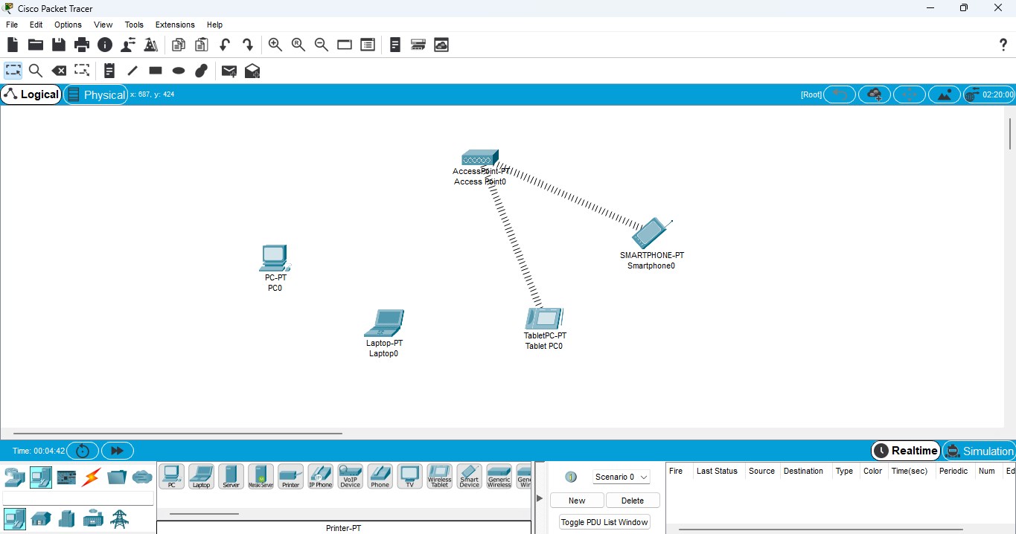

Select PC-Physical-CPU Off-Remove Port and Add Default-Port.

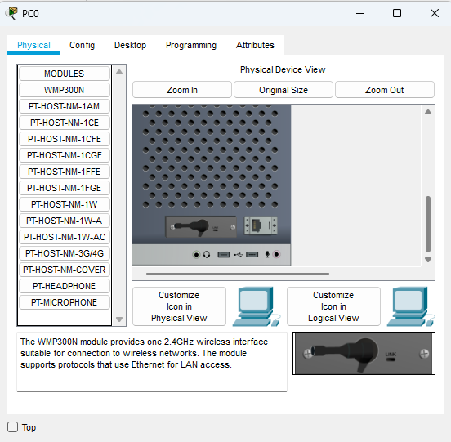

Select Laptop-Physical-Switch Off-Remove Port and Add Default-Port.

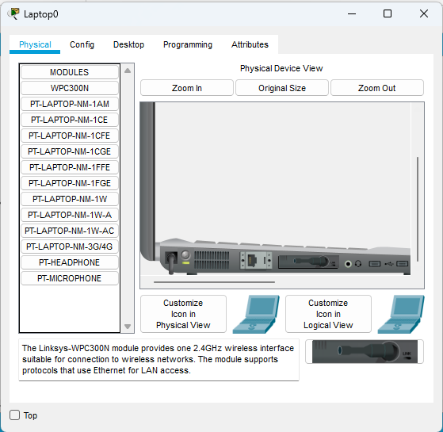

Select Access Point-Config-Port 1-Name SSID –Click Authentication-WEP”0123456789”

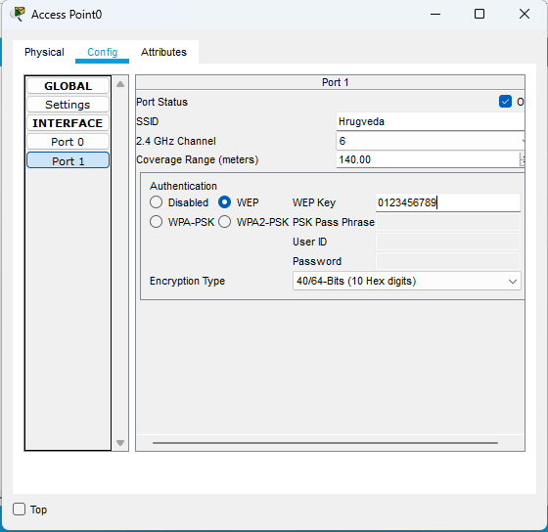

Select PC-Desktop-PC Wireless-And Connect to Wireless Network name.(same as to Laptop.)



For Connecting-Enter WEP KEY 1- “0123456789” and Connect.

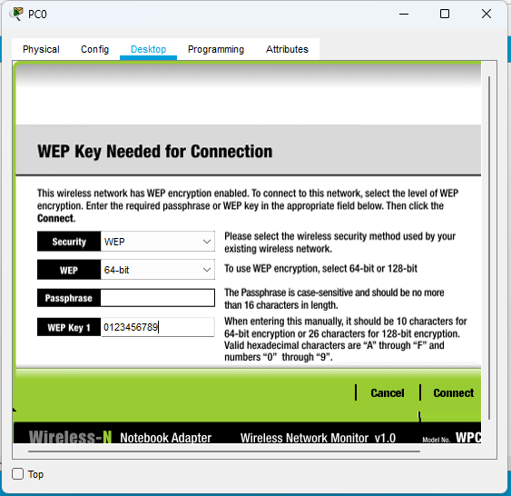

Select Tablet PC0-Config-Wireless0-Enter SSID and in Authentication-Enter WEP.

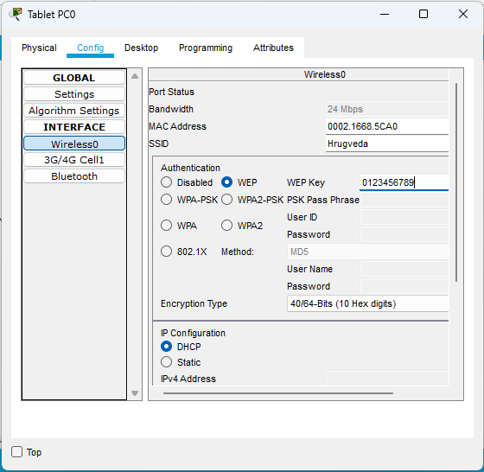

Select Smartphone0-Config-Wireless0-Enter SSID and in Authentication-Enter WEP.

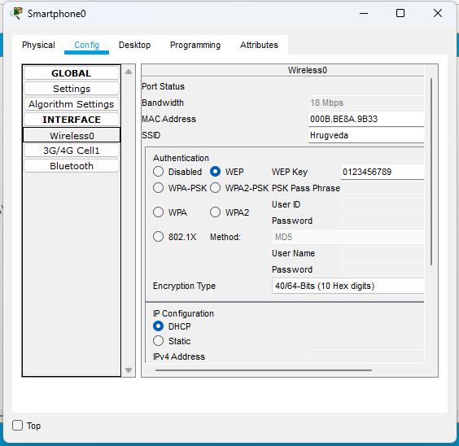

All devices connected .

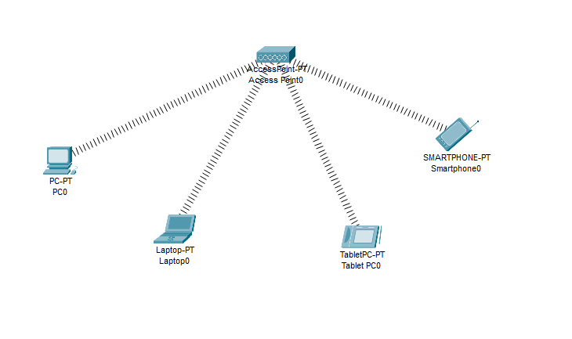

Packet Send Successfully.

